Statistics - Worksheet B answers

1 a 2, 4, 5, 5, 6, 7, 7, 8, 9, 10, 12, 18, 23
b i Min. = 2, max. = 23 ii 21 iii 5 and 7 iv 8.9
v 7 vi Q₁ = 5, Q₃ = 11 vii 6 viii Yes, 23
c
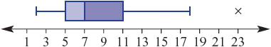

2 a
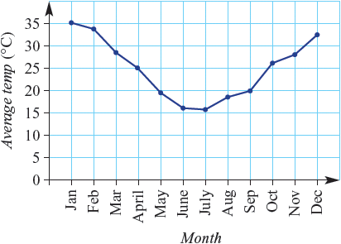
b The average maximum temperature decreased until its minimum in July and then
increased, trending back to higher temperatures by the end of the year.
3 a
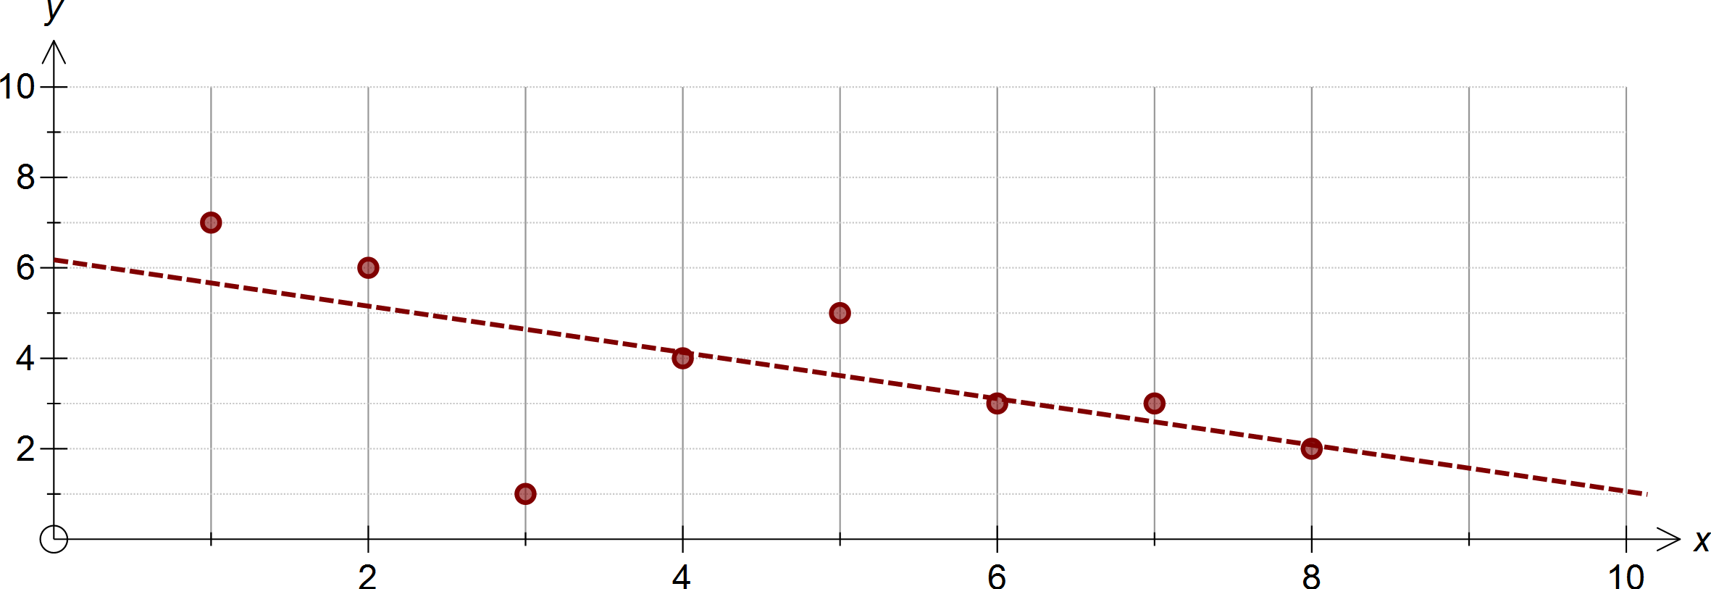

b Negative c Strong d The outlier is (3, 1)
e See scatter plot
f i 4.9 ii 6.1 iii 9.1 iv 1.3

